SUBMITTED BY: Saurabh Sinha

TOPIC: 5 features on websites (2 college websites) that can be improved with regard to a design perspective and how can they be improved.

INSTITUTE 1: NIT SILCHAR (nits.ac.in)

1. Using texts as images:

Given the particular section of the webpage, the images can be seen as screenshots individually, or screenshot from a source, which in not given, as the images seem to have as the image(s) appear to have a low resolution and are indistinct.

Way to improve: Rather than providing a single image as a source of the rankings, they can either be placed in the same fashion with distinct images linking them to their respective sources, or, in case of the graphs given, they can be plotted to add benefit to the responsiveness of the webpage.

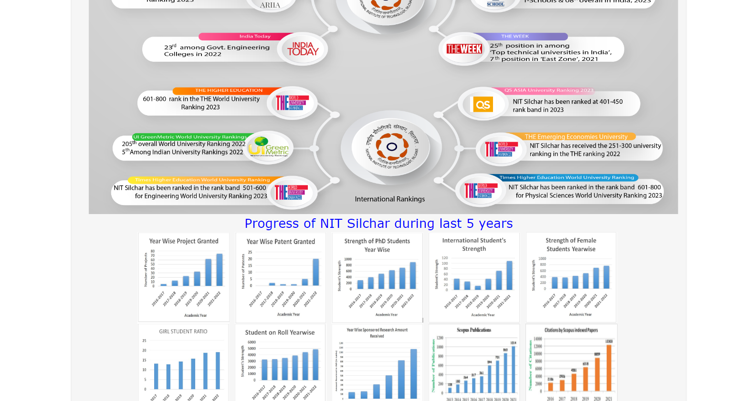

2. Way too many “Menu” Options:

The options on the right side of the home icon as given in the image below are way too many and in many cases may seem to be out of interest to any user trying to toggle through the options.

Way to improve: Many of the options can be added as submenu, such as given “COVID-19”, “Training and Placement” or even the “International Student” section can just be added under the particular sections such as Academics, if it is academic related or even gallery, if the website wishes to showcase any event/program related to international students.

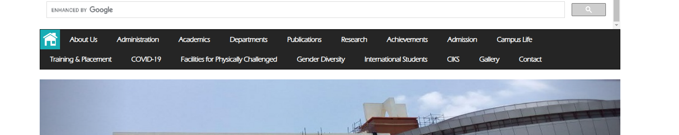

3. Language dropdown can be swapped with toggle as only one language is included:

As given below, only one language other than English is included in the website, which is hindi. Using google translate may lead to incorrect wordings and inconsistency in the meanings.

Way to improve: Other languages such as Bengali, Kannada must be included in the website, which adds benefit to the subjectivity to the already objective website, and make the website more user-friendly.

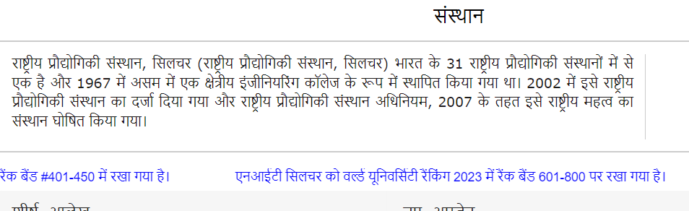

4. Not much contrast in color:

For most of the parts the webpage appears to be plain and to add contrast, black is added as the background color to some of the sections. A server’s contrasting colors are crucial to users having vision problem, and it is important to users viewing the content.

Way to improve: Add more color to the server which are not very contrasting to each other, such as blue or even gold in the section the webpage wants to highlight the most, highlight the important features with a color having the highest wavelength, and if the content is searched using the search bar given in the website and if it is present in the home page itself, the particular keywords searched must be highlighted in a color having a high wavelength, such as red to signify that it the content the user desires.

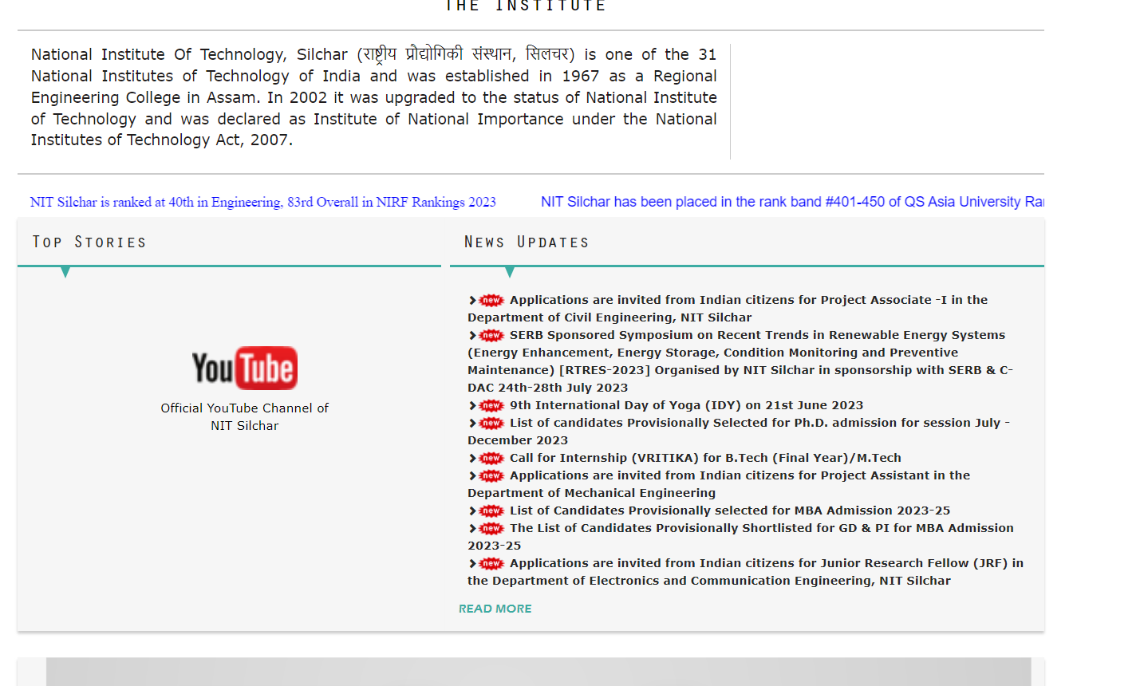

5. Complex quick links section/Readability issues:

The quick link section as shown in image below has too many options with a smaller font size which may not appear to be appealing to many viewers, causing the viewers to leave out sections of the quick link which may be prominent to them.

Way to improve: Just like earlier, add subsections and this time the links must appear when the cursor is toggled over the main section content and reduce the number of quick links and this can be done by adding similar content of one link to the other.

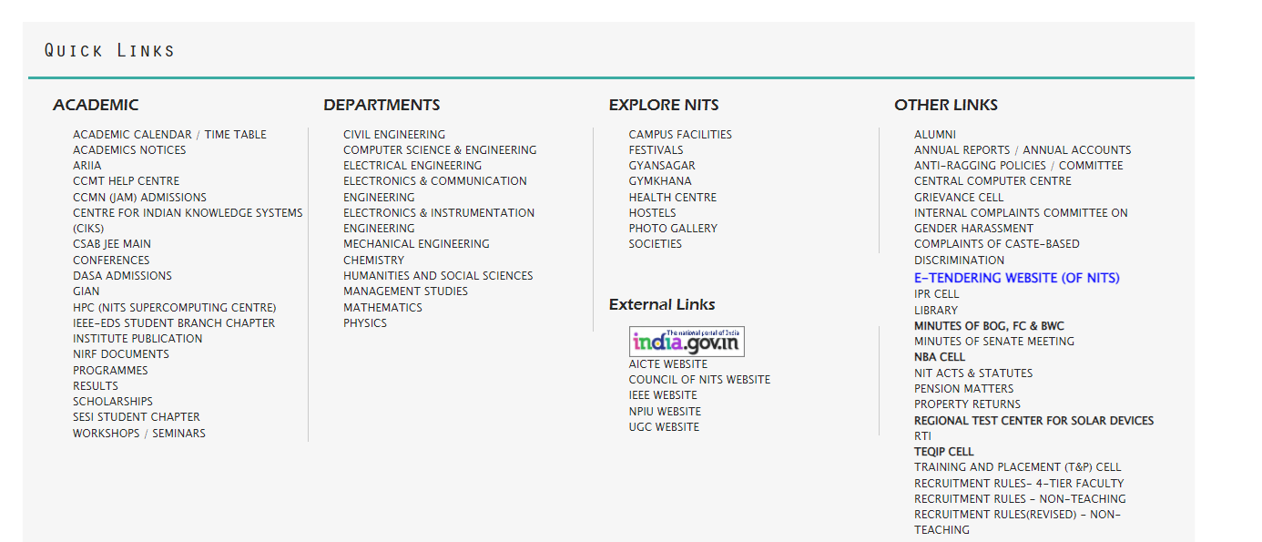

6. Inconsistency in one of the quick link pages:

In the images given below, a user understands that the webpage is attempting to pass on information about what the page is related to, but it may all come in expense with the user experience as there is indefinite font sizing, missing colors, borders and missing additional effects such as fade effects which may credit to the user’s appeal.

Way to improve: The texts of the different sections may be aligned from the left and right side to avoid white spaces, contrasting colors can be added to improve readability.

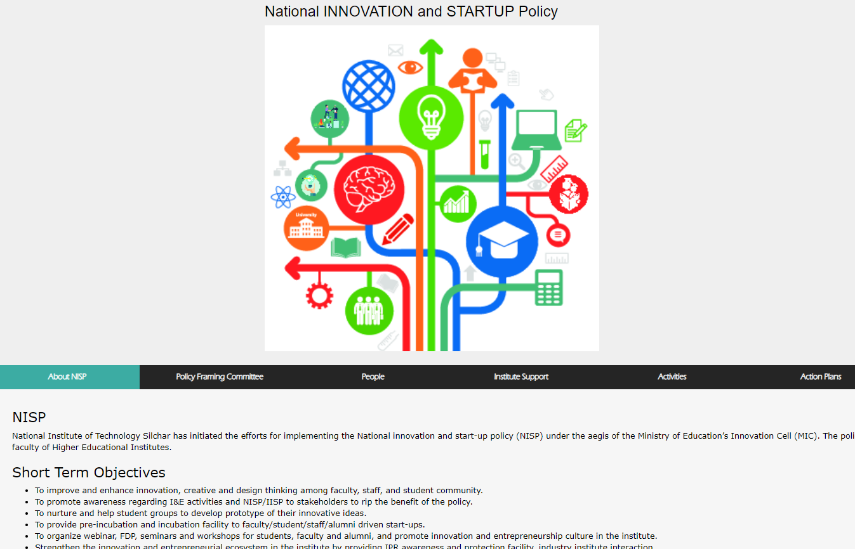

7. Limited responsiveness:

A website having a responsive design is considered user-friendly, adapts to the user’s toggle and viewpoint. The NIT Silchar website has limited attention to the responsiveness of the website.

Way to improve: The webpage shall be objectively made to be adaptable to a user’s viewpoint, the hardware upon where the webpage opens shall be considered, and importantly the webpage shall adapt to zoom in/out features.

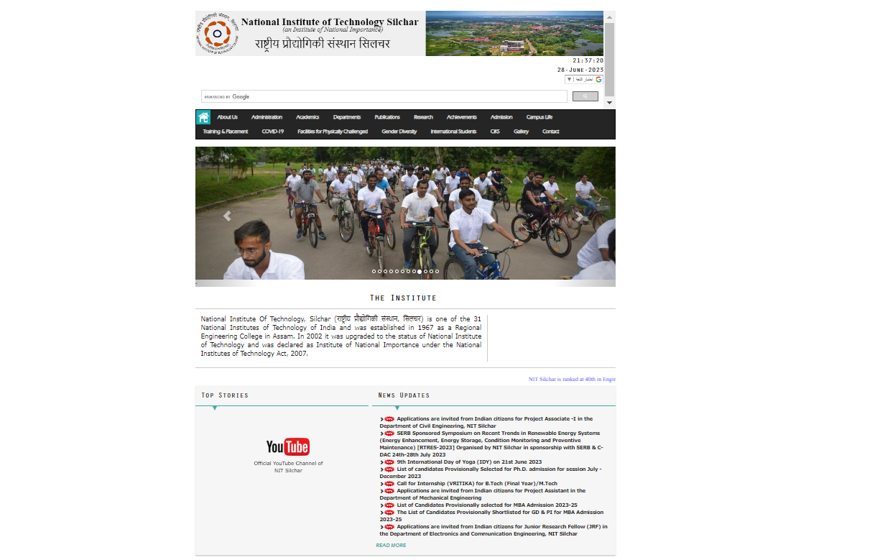

INSTITUTE 2: NIT MANIPUR

1. Absence of a Search Bar:

In any website containing a substantial amount of content, a search bar is necessary as it pinpoints to the page/location the user desires and benefits a user’s experience by saving their time.

Way to improve: The website may add a search bar on the top right hand side or as a separate section between the logo and the menu section.

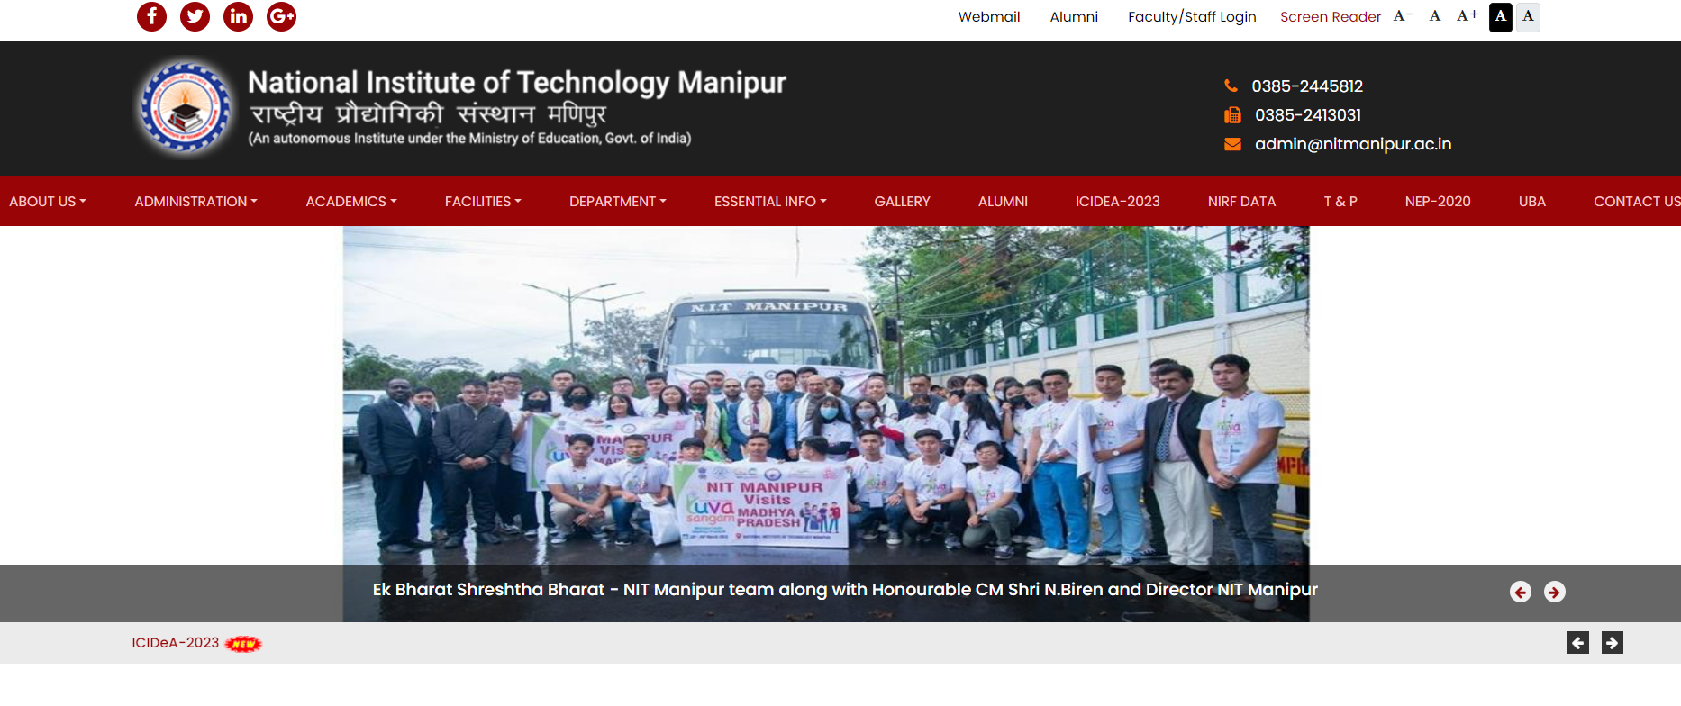

2. White spaces between content:

As we scroll down the webpage we get to observe a considerable amount of white spaces which may be inefficient in terms of design and it may cause a viewer to lose interest in the webpage they are visiting.

Way to improve: Reduce the amount of white spaces by adding more content in the spaces which may interest the viewers, or even re-organization/re-structuring of the content.

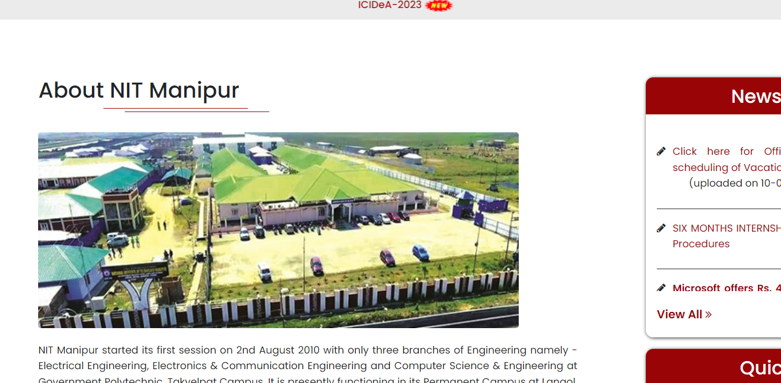

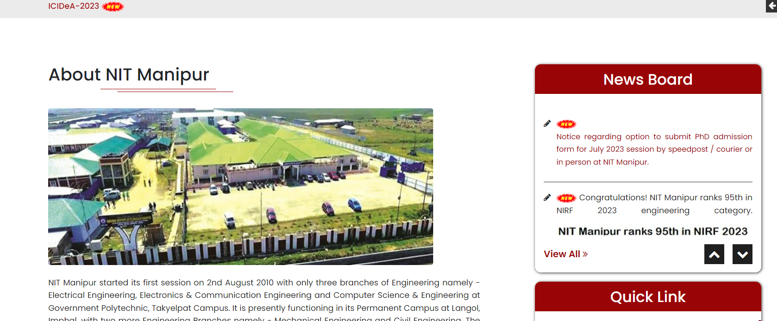

3. Website images are unresponsive:

When we initially visit the website, upon zooming in/out, the images present at the initial stages seem to be not responsive to the user’s control, so the viewer may find it inconsistent and not appealing.

Way to improve: Add responsiveness to the images as it will benefit the user experience, and make the images adapt to the viewer.

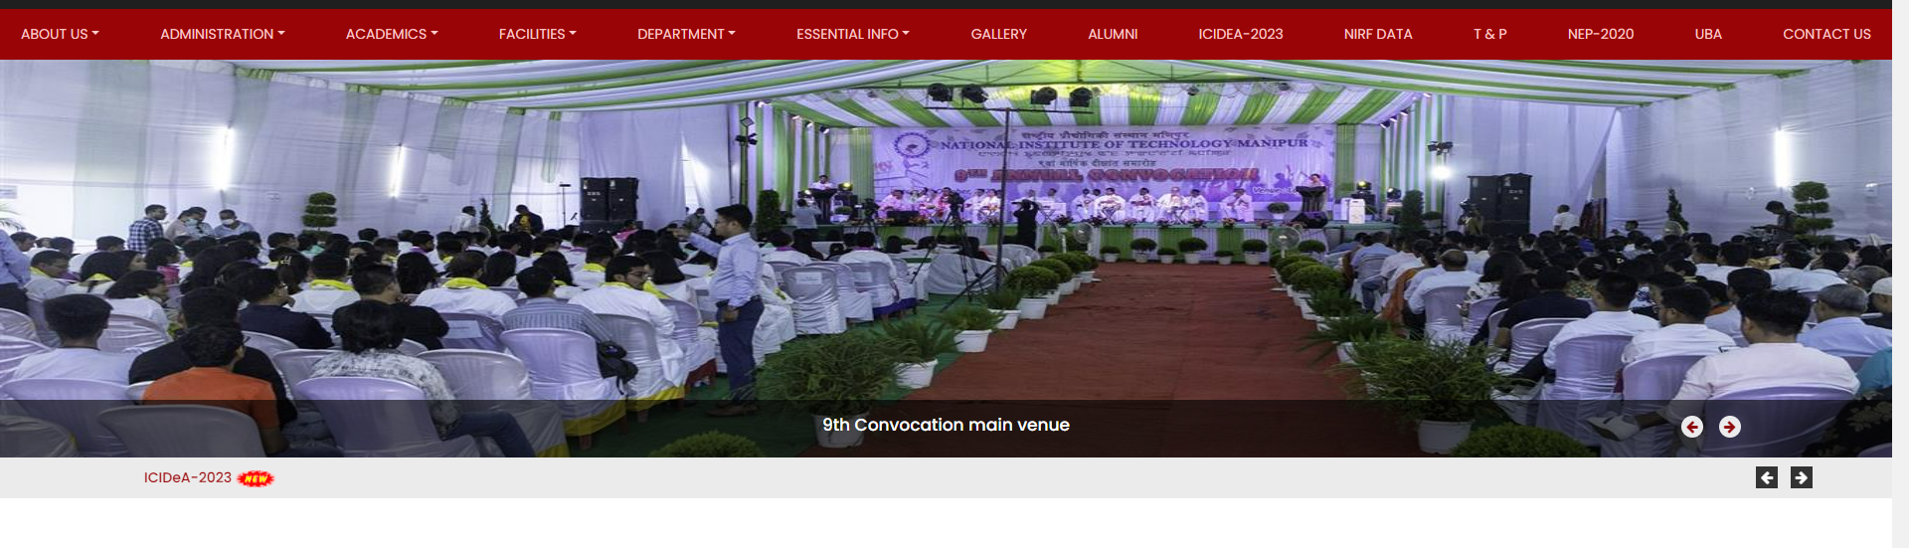

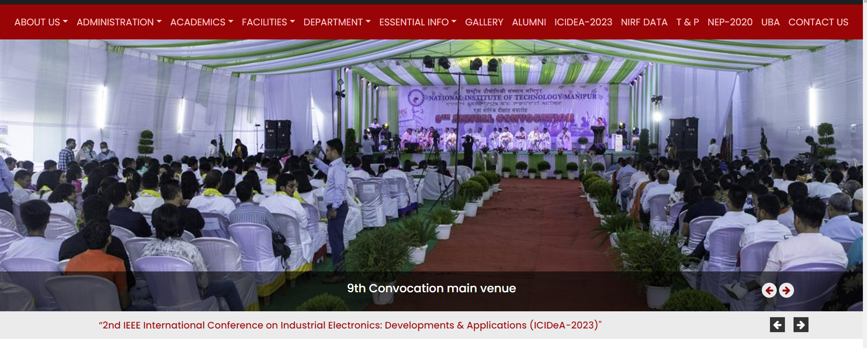

4. Lack of accessibility:

Given in the image below, as we scroll down the webpage and arrive at this particular section and whenever we try to click any link, it redirects us to top of the page. Basically, the content given in the links as shown in the page is synonymous to the content at the main menu of the page, hence the redirection. This in turn causes lack of accessibility and the viewer may find it difficult to open particular sections of the webpage which they may need.

Way to improve: Rather than re-directing to the top of the page, it would be much better if the option directs the viewer to the link/page instead. For example, if viewer clicks on “campus facilities”, it would improve the user experience if the viewer is redirected onto the page having the essential information rather than being redirected onto the top of the webpage.

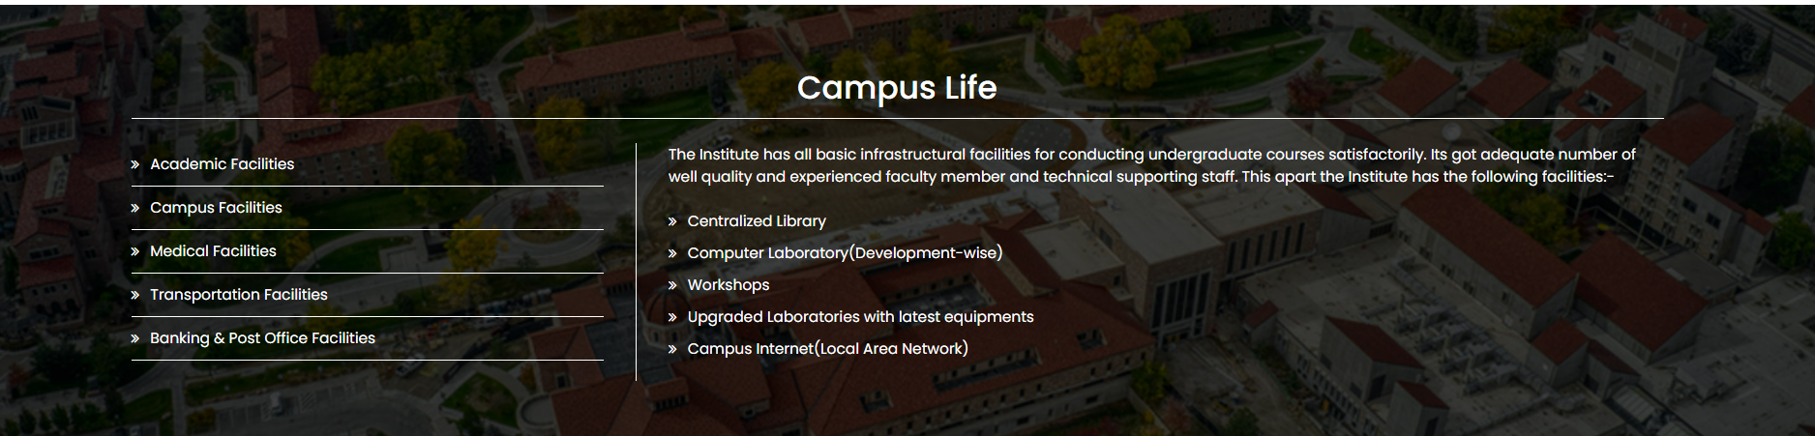

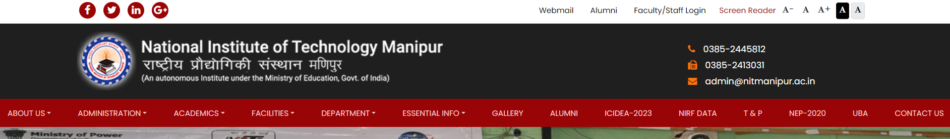

(Clicking on any option on the first image redirects us to the section of the page as given in the second image)

5. Inconsistency in layout and Outdated design:

As we can see in the website itself, to approach a particular section such as gallery or even the achievements, we will have to scroll down the webpage in order the view the content at times. Most of the images have low resolution and the layout in some areas are inconsistent. For example, the photo gallery at the end of the page consists of just photos without any background knowledge.

Way to improve: Images shall have better resolution as they can be more attractive. Achievement section can be added in the main menu and some important images with background details can be added as a subsection to the achievement section which can be termed as “events”. The gallery may also serve as a separate section in menu where subsections such as “convocation” or “Founder’s day” can be added to improve diversity, and prevent scrolling to find the content.

